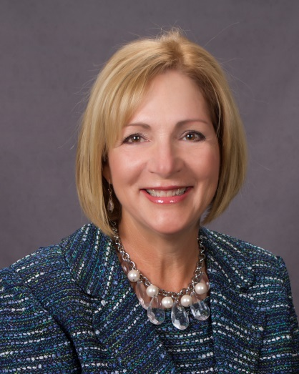

How To Be A REAL Success
Presenter: Debby Davis, Business Development Director, Computer Services, Inc. (CSI)
Based on the John C. Maxwell’s REAL Leadership, to become a REAL success it is imperative to Relate to others better as you understand relational rules; Equip others with the proper skills sets; improve your Attitude through daily practices; and Lead others successfully to where you have gone and beyond.
With over 25 years experience in banking and technology, Debby Davis has studied and personally implemented the philosophies behind personal development and the role emotions and vision play in leadership. She uses candor, humor, insight, and passion with the intent to help organizations and individuals solve problems and execute on strategies that produce a measurable impact on their long term sustainability. How To Be A REAL Success will make a lasting impression on helping you continue to grow as a leader, and much more.

